**Let Happiness Happen Mirror Wall Art**

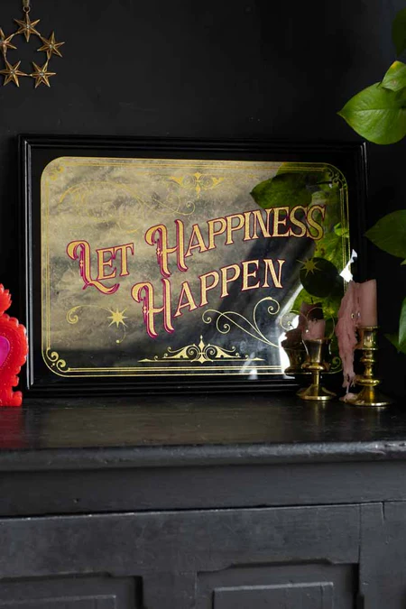The **Let Happiness Happen Mirror Wall Art** is a beautiful and uplifting addition to any space. With a message of positivity and joy, this mirror features the inspiring phrase "Let Happiness Happen" in an elegant design that encourages an optimistic mindset. The sleek reflective surface is framed with subtle, modern details, making it a perfect fit for living rooms, bedrooms, or any area in need of a cheerful touch. This mirror not only serves as a functional piece but also as a constant reminder to embrace happiness and live in the moment, bringing both style and positivity to your home.